gulp-sass a gulp-compass využívají ruby gem – nutno nainstalovat nicméně je potřeba mít starší gemy kvůli bugu viz postup níže

To get it to work in 32 or 64bit windows, I done what Min Ren suggested but I also had to manually clean the gem repository (C:\Users\myusername\.gem\specs\rubygems.org%443\quick\Marshal.4.8) of all the sass and compass gemspec files after the uninstall steps. I also installed sass before compass.

gem uninstall compass

gem uninstall sass

manually clean .gem

gem install sass --version "3.2.10"

gem install compass --version "0.12.2"

function initUrls() {

AUI().ready('liferay-portlet-url', function(a) {

var resourceUrl = Liferay.PortletURL.createResourceURL();

resourceUrl.setPortletId('newnoteportlet_WAR_newnoteportlet');

resourceUrl.setResourceId('saveNote');

saveNoteUrl = resourceUrl.toString();

});

}

User management settings

* You have to set your password policies (turning off change request) Control panels - users – Password policiies
* evrem-user role must exist
  + This role should have view permision for Evrem site (also must exist) for every portlet

Zvýšení délky sloupce v souboru portlet-hbm.xml alternativně v portlet-model-hints.xml nicméně to asi nefunguje, pro jistotu v obou souborech.

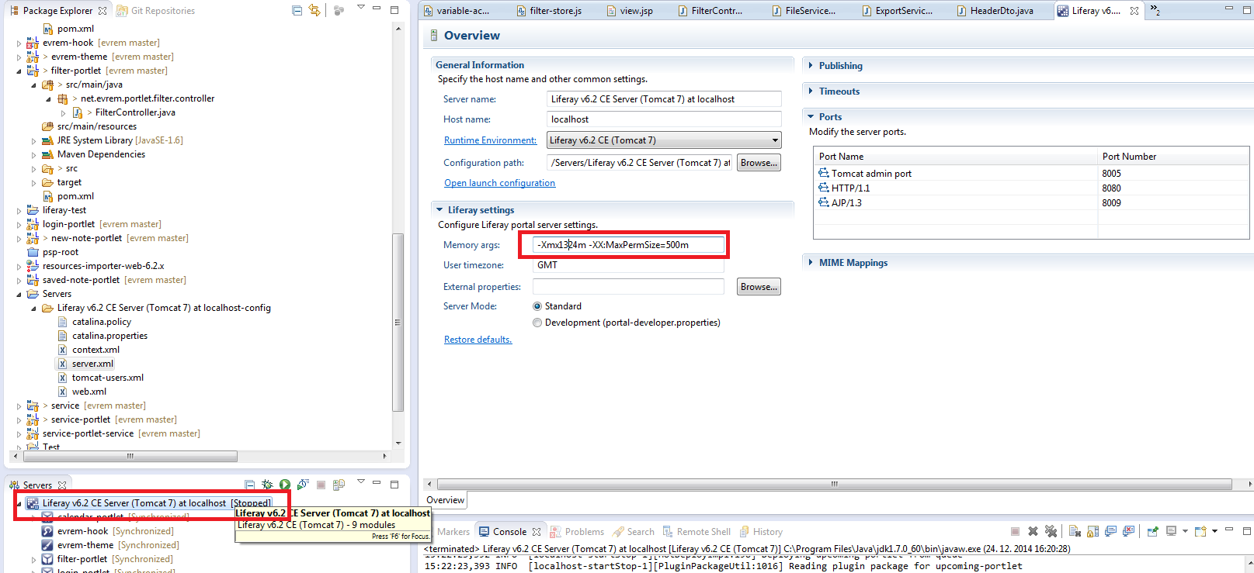

Mail settings in portal-ext.properties are only used when the portal is started the first time, they are used to populate the database. From that point on the GUI is used.

Server administration - Mail

host=smtp.gmail.com

HaisenBug456

port=465

user=evremapp